**5.1 Assignment**

**(a)**

Top 5 employees (employee id and employee name) with highest rating. (In case two employees have same rating, employee with name coming first in dictionary should get preference)

**Solution**

// Load data from text file to pig –x local

**emp_details = LOAD 'employee_details.txt' USING PigStorage(',') as (emp_id:int,emp_name:chararray,emp_salary:int,emp_rating:int);**

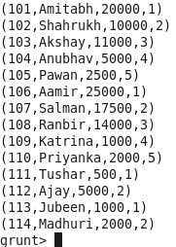

//grouping emp_details

**emp_analysis = foreach (group emp_details all)**

**{**

**//** ordering fields based on the ratings as descending and ordering name as alphabet wise

**sort = ORDER emp_details by emp_rating DESC,emp_name ASC;**

**//** displaying 1st 5 rows

**result = LIMIT sort 5;**

**generate flatten(result);**

**}**

**emp_result = foreach emp_analysis generate result::emp_id,result::emp_name;**

//displaying processed data

**dump emp_analysis**

**Final output for (a)**

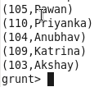

**(b)**

Top 3 employees (employee id and employee name) with highest salary, whose employee id is an odd number. (In case two employees have same salary, employee with name coming first in dictionary should get preference)

**Solution**

// Load data from text file to pig –x local

**emp_details = LOAD 'employee_details.txt' USING PigStorage(',') as (emp_id:int,emp_name:chararray,emp_salary:int,emp_rating:int);**



// Filtering odd ids

**filter_id = FILTER emp_details BY emp_id %2 == 1;**

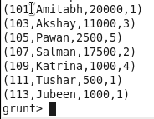

// grouping above output

**emp_analysis = foreach (group filter_id all)**

**{**

**//** ordering fields based on the salary as descending and ordering name as alphabet wise

**sort = ORDER filter_id by emp_salary DESC,emp_name ASC;**

**//** displaying 1st 5 rows

**result = LIMIT sort 3;**

**//** generating group to fields using flatten

**generate flatten(result);**

**}**

//displaying processed data

**dump emp_analysis**

**Final output for (b)**

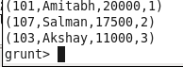

**(c)**

Employee (employee id and employee name) with maximum expense (In case two employees have same expense, employee with name coming first in dictionary should get preference)

**Solution**

**emp_details = LOAD 'employee_details.txt' USING PigStorage(',') as (emp_id:int,emp_name:chararray,emp_salary:int,emp_rating:int);**



**b_emp_details = LOAD 'employee_expenses.txt' as (emp_id:int,emp_expense:int);**

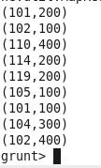

**//**joining two files using id as common

**c = join emp_details by emp_id,b_emp_details by emp_id;**

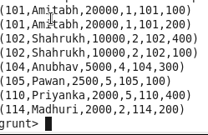

**sort = ORDER c by b_emp_details::emp_expense DESC,emp_details::emp_name ASC;**

**result = foreach sort generate emp_details::emp_id,emp_details::emp_name;**

**dump result;**

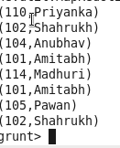

**(d)**

List of employees (employee id and employee name) having entries in employee_expenses file.

**Solution:**

**emp_details = LOAD 'employee_details.txt' USING PigStorage(',') as (emp_id:int,emp_name:chararray,emp_salary:int,emp_rating:int);**



**b_emp_details = LOAD 'employee_expenses.txt' as (emp_id:int,emp_expense:int);**



**c = join emp_details by emp_id,b_emp_details by emp_id;**

**result = foreach c generate emp_details::emp_id,emp_details::emp_name;**

**dump result;**

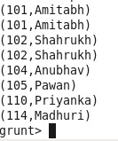

**(e)**

List of employees (employee id and employee name) having no entry in employee_expenses

file.

**Solution:**

emp_details = LOAD 'employee_details.txt' USING PigStorage(',') as (emp_id:int,emp_name:chararray,emp_salary:int,emp_rating:int);



**b_emp_details = LOAD 'employee_expenses.txt' as (emp_id:int,emp_expense:int);**



//left outer join

**c = join emp_details by emp_id LEFT OUTER,b_emp_details by emp_id;**

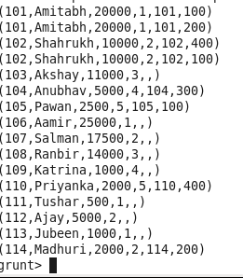

**filter_id = FILTER c BY b_emp_details::emp_id is null;**

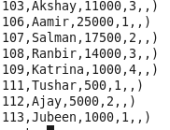

**result = foreach filter_id generate emp_details::emp_id,emp_details::emp_name;**

**dump result;**

